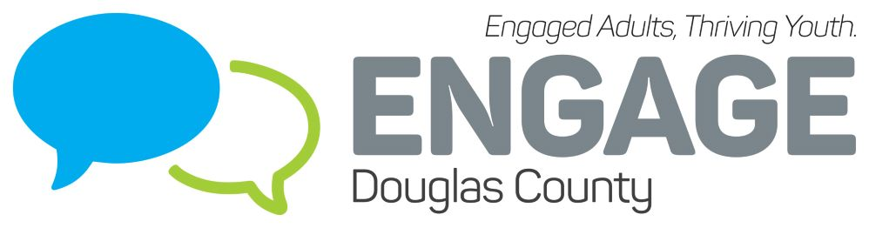
Engage Douglas County
August 24th, 2022
1:30-3:00 PM
Baker Wetlands Discovery Center
Mission: Mobilize and empower Douglas County to reduce substance abuse and promote mental health primarily among youth through action, education, and collaboration.

Welcome and Introductions – The coalition broke into small groups to discuss the following questions:
- What are some needs you see related to substance use and mental health among youth in Douglas County?
- What is a goal you have for Engage Douglas County for 2022-2023?
- What is one thing you’re hoping to gain by being involved in Engage Douglas County?
Report out: One group discussed the idea of having three caring adults in your life. When a young person knows what their spark is and they connect with 3 significant adults who are not their parents, they can connect a young person with opportunities to help them thrive. The students who are most at risk thrive the most. They also discussed normalizing behaviors that don’t include substance use, starting earlier with self-care plans and setting boundaries. The second group discussed an overall concern of substance misuse particularly fentanyl and students not realizing the fatality of using it. They also talked about the mental health of students and staff within school districts and the ongoing process of supporting that. The third group discussed the lack of diversity in providers in Douglas County; if people are seeking services and they don’t see providers that represent them, how likely are they to engage in services? They also discussed opportunities for sharing about specific services in specific groups that don’t have the same type of access to resources including geographic access to services. The fourth group discussed that self-medication is a common issue for students, MH and substance misuse ties into IPV. What can we do to be help not only youth but the family system? They also talked about peer pressure and teen relationships and the connection between that and substance use. The fifth group discussed the need for resources locally that are available, particularly MH services for youth. There are amazing Douglas Co orgs but we definitely have capacity issues and MH therapies that aren’t available in the community. In addition, they talked about the lack of candid conversations with young people about vaping; basic education about what vaping does to your body and allowing them a space to ask questions.
Marijuana Workgroup Update - Data that was collected from the adult survey was used along with KCTC student survey data to create social media campaign messages targeting both youth and adults in DgCo. Sample ads from the campaign were shared. Create Uplift collected responses and engagement data to compare positive norm messages vs factual messages and determined that the positive norm messaging had a much greater engagement and response. It was also determined that EDC campaigns have and still are saturating social media platforms. It is recommended that we venture into printed messaging to focus on getting materials out into the communities via schools, organizations and businesses. i.e. posters, window clings, rack cards. Create Uplift can develop a toolkit for this that includes materials for social media and print, then distribute that to the coalition and any other organizations who may want to utilize it. Tobias is still trying to find a connection for Lawrence bus ads. What other ideas do coalition members have to reach adults and youth in the county with these messages? The group suggested the following: hosting half time activities at high school sporting events that help spread awareness of the messages we’re trying to share, putting ads on digital boards (IE the bank on 6th street), providing social media that school accounts can share, bathroom flyers, have “local celebrities” in Baldwin, Eudora, Lecompton, and Lawrence be part of the messaging, PSA on school district’s channels, hopeful messages for parents that they can learn more and do more, script of talking points provided to schools, community groups, and faith groups to share both positive social norm information and risks of use, partnering with Theatre Lawrence and the Lawrence Arts Center, grocery stores – brochures at the counter, flyers in bags, window clings on the sneeze guards that they put up for Covid, yard signs.
Alcohol & Tobacco Retailer Assessment, Reward and Reminder, and Tobacco Retailer Assessment – Please see slides at the end of the notes. The group suggested engaging the chamber with this information and conducting survey of retailers regarding challenges they face with the issues that were identified.
E-Cigarette/Early Intervention Grants – DCCCA is providing $1250 in funding from KDADS for any youth-serving organization in Douglas County (including schools) to host an after-school activity or event targeted towards middle or high school aged youth. These activities can range from a volunteer opportunity, art club, a basketball tournament, a post-prom activity, or anything you think the youth in your community would enjoy. Activity must be completed by March 31, 2023. For more information, reach out to Ariel at acohn@dccca.org.
Suicide Prevention Coalition/Engage Douglas County Merger – The Douglas Co Prevention Coalition is dissolved/merged into Engage Douglas County. There will be a sub-committee for suicide prevention. Meg can help guide that for now to get it going. If you’re interested in being part of the workgroup let Lydia know. The funds from Douglas Co Prevention Coalition has been transferred to EDC and those funds are earmarked for suicide prevention. Suicide Prevention Month is September, it is short notice to do something new but there are some happenings:
- Youth Suicide Prevention Art Contest – ksphq.org/art-contest. For artists grades 6th-12th. Submissions close at 9:59 PM on September 30th. They are also looking for youth judges, if you know youth who are interested let Meg know.
- Breakfast for Hope on September 8th at 8:00 AM. Coffee, fresh food, live music, special guests, celebration. Reserve tickets in advance (free) at https://prevent-suicide.networkforgood.com/events/40500-988-breakfast-for-hope
- Engage Douglas County partners are also invited to participate in Let’s Chalk About Suicide event – chalk messages of hope and help and post it on SM and tag KSPHQ. https://www.ksphq.org/chalk/
DCYP/Sources of Strength – Baldwin High School is now trained in Sources of Strength. There will be a county kick off Kick Off Sept 19th for all DCYP and Sources of Strength groups at Flory Meeting Hall on the Douglas County Fairgrounds.
Douglas County YES - Douglas County Youth Empowerment Summit (YES) is a one day event held on Tuesday, October 25th (during Red Ribbon Week) from 8:00 AM to 2:30 PM at Arterra Event Gallery in Lawrence. The objectives set by the youth are 1) build leadership, prevention, and advocacy skills 2) learn about implementing special projects to promote healthy lifestyles and 3) enhance your capacity to be a change maker in your school and community. The goal is for groups to walk away with an action plan to implement activities at their school related to substance misuse prevention and/or mental health. Sessions will be led by youth (either high school peers or KU students) and community partners. Registration is open: https://www.dccca.org/events/youth-empowerment-summit/
Open Collaboration
- DCCCA has a statewide Mental Health First Aid Project funded by KDADS. They will be training 64 instructors throughout the state on youth MHFA and adult MHFA in October, November, and January. Instructors will receive $1,000 stipend to purchase materials for MHFA classes. They are also offering 9 free classes between now and March, providing youth and adult MHFA training. Share far and wide. Contact Chrissy (cmayer@dccca.org) or Ariel (acohn@dccca.org) for more information.

- 988 is now not only a suicide prevention line but also a crisis line in the hopes of providing a larger continuum of care. They are rebranding to Suicide & Crisis Lifeline. Historically there has been a misconception that you have to be suicidal to reach out to the lifeline but the goal is to assist people in crisis or people witnessing crisis. There has been some negative communication centered around 988 and police involvement. EMS or police may be dispatched if there is an imminent risk but at KSPHQ which serves 103 of 105 counties, they dispatch LE less than 2%. 988 is not currently connected to geolocation – use 841-2345 if possible to be routed to KSPHQ. You can text 988. It is geo-linked via IP address if you’re using the chatline.

- Let’s Text - https://www.letstalklawrence.org/lets-text

- Peer Fellows Program – The county has a program that provides integrated peer support throughout system of care. Every Thursday they have a seminar for peer fellows; starting soon, some seminars will be held at the library or community setting to broaden reach and offer more BH training opportunities for those who are passionate about it. If you’re interested in being involved or learning more, contact Bob.

